**Build Maven Project Without Git Plugin**

Date: 25-02-21

Itay Hauftman:

1.) Go through video which is downloaded in class directory

2.) For **Workspace** option in creation of **new item** install Workspace plugin for maven

3.) For creating Workspace

*Manage Jenkins->Configure System->Workspace Sharing*

Here give repo url and workspace name as you wand

give repo url and workspace name as you wand

4.) In Maven build project

**Build**

**Execute windows batch command**

**Command:**

mvn install –f <path to pom>/pom.xml

Note: give that path to pom.xml file which you’ll get after cloning your repo from Git_clone project

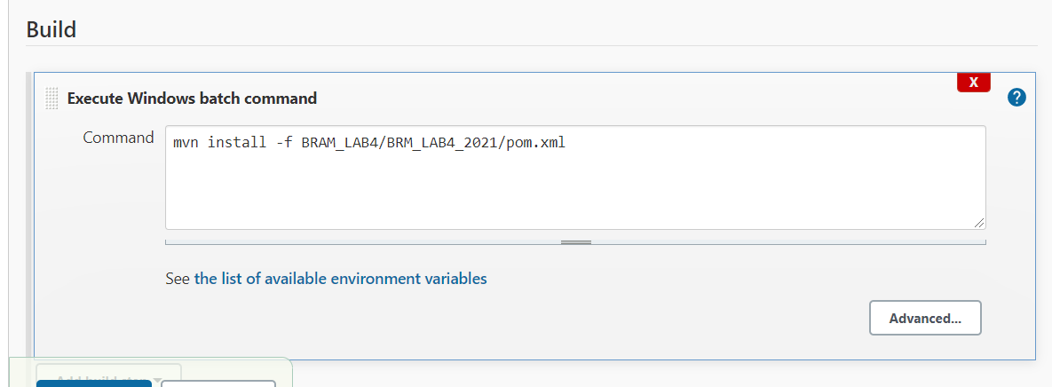

|  |  |  |  |
| --- | --- | --- | --- |
|  | | | |
|  |  |  |  |

*Because maven’s workspace is workspace one just out side.*

